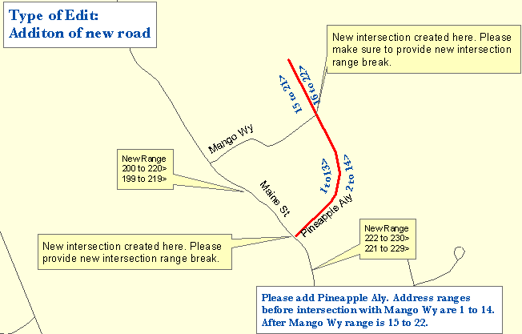

One Maine Enhanced 9-1-1 Update Form will need to be filled out for the above edit. The following sections are found on MSAG Update Forms and serves as an example as to what information needs to be provided to Emergency Services Communications Bureau/GIS in order to complete the edit. In addition, please provide all the information noted on the map above by marking it on a copy of the map book page. Please submit both the map book page and the Update Form to Emergency Services Communications Bureau/GIS.

FORM 1

- □ A. New Street : |  |  | Effective Date: 1/23/2003
1. Street Name: Pineapple Aly | 5. Number range: low_1_ high_22
2. Closest Intersecting Street: Maine St | ___odds ___evens _x_both
3. Address Off Intersecting Street: 220 Maine St
4. Addressing Interval: |  | - 25 ft. |  |  | - 50 ft. | - Other
Remarks: Pineapple Aly intersects Mango Wy at #14 (see map)

- □ E. Address Range Change | Effective Date: 1/23/2003
Street Name: Maine St
Reverse direction of numbering | Reverse odds/evens
Number range change: ___Odds ___Evens X Both
Old range: low __199 high_230
New range: low __199 high 220

Remarks: intersection range change (see map)

- □ E. Address Range Change | Effective Date: 1/23/2003
Street Name: Maine St
Reverse direction of numbering | Reverse odds/evens
Number range change: ___Odds ___Evens X Both
Old range: low __199 high_230
New range: low _221_ high_230

Remarks: intersection range change (see map)

